Sustainability Initiative: Energy Efficiency

Name
Institution Name
Course/Number
Due Date
Faculty Name
Sustainability Initiative: Energy Efficiency
Determine and define who, inside and outside the organization, is essential in the success of your initiative.
Implementing an energy efficiency initiative that with a lasting sustainability requires participation from multiple stakeholders. Such participants range from senior healthcare executives to department-level advocates. Among the people who are essential in the success of these initiative include the healthcare administrator in the facility, all the medical personnel, directors of the facility, the department of health in the local and state government, the patients, non-health staff, and the leaders in the immediate community.
Partnerships to Foster Collaboration or Healthy Competition
The healthcare organization can partner with relevant organizations managing energy efficiency programs such as Leadership in Energy & Environmental Design or ENERGY STAR. Such organization would be crucial in the procurement of energy efficient equipment. They will also assist in the installation of the energy efficient equipment and creation of strategies to save energy.
Strategies to Engage Patients and Their Friends or Family in the Initiative
Patients and their friends or family will be involved in the project by showing them the benefits of the energy efficiency initiative and asking for their active contribution for the overall success of the initiative. A culture for supporting the initiative will be installed by letting the patients know when the lights will be switched off as well as efficient use of the rooms’ heating systems. Their families and friends can be given fliers detailing the objectives of the initiatives with an option to give donations if they see it necessary.
Community Leaders Who Can Use Power and Influence to Further the Initiative
The community leaders who can use their power and influence to further the initiative include local business leaders, school officials, community activists, and local church leaders. These leaders will influence people to champion and implement the sustainability efforts. By showing that the initiative intends to lower the cost of health care, the leaders can be convinced that the initiative is beneficial to the community and they will convey the same to the people.
Script for A 60 Second Online Advertisement
Hospitals and care systems are increasingly looking for ways to promote efficiency and reduce the cost of operation while striving to improve the overall patient experience. This is why we are advocating for energy efficiency as a sustainability initiative to lower the cost of energy during healthcare delivery and the subsequent cost of healthcare for the community. This initiative will be beneficial in multiple areas; the effort will contribute to healthier environment and improve the facility’s public perception. It will also reduce the operational costs, thereby allowing the hospital to direct more resources to patient care.
Creating alternative energy sources in the hospital will lower the utility costs and mitigate power interruptions, especially during disasters. Besides, there are several state and local initiatives to reduce energy use and adopt the green building codes. We call upon the healthcare and community leaders to ensure that the efforts for energy efficiency will be implemented in the hospital setting. This can be done by installing new energy efficient lighting that will lower the energy used as well as the maintenance costs while offering the lighting that is optimum for clinicians to provide healthcare services. Lighting comprise more than 10 percent of the total energy used in hospitals and this provides an opportunity for significant savings.
The community is invited to be part of the energy saving initiative in the hospital. Everyone can participate by making donations for the implementation of the initiative. They can also enlighten others on the expected benefits and promotion to a green environment.

Storyboard for the Advertisement

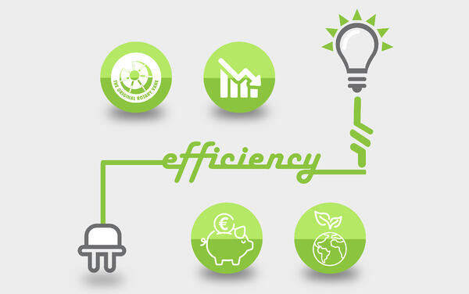 | 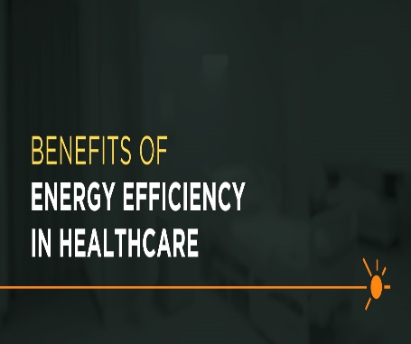 | 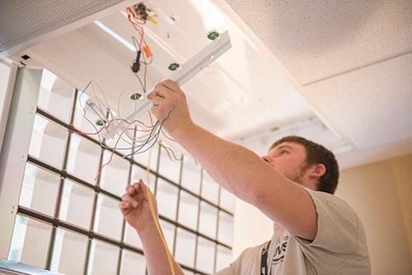
Promoting Green Environment through Energy Efficiency | Numerous Benefits of Energy Efficiency in Healthcare | Installing Energy Efficient Equipment
Hospitals and care systems are increasingly looking for ways to promote efficiency and reduce the cost of operation while striving to improve the overall patient experience. This is why we are advocating for energy efficiency as a sustainability initiative on energy efficiency. | Creating alternative energy sources in the hospital will lower the utility costs and mitigate power interruptions, especially during disasters. | Energy saving lighting equipment and use of alternative on site energy sources will be crucial in fostering energy efficiency.  The community is called upon to support the initiative

Social Media Posts for the Initiative
Being energy efficient is one of the guaranteed ways to reduce Healthcare spending.
Be part of the change by supporting the initiative
Memorial Hermann Health System saved $47 million over five years by implementing energy efficiencies.

- Energy efficiency in hospitals will allow the hospitals to direct more resources to patient care.
- This can be seen inferred from hospitals who have adopted energy-saving strategies.
- The University of Arkansas for Medical Sciences saved enough through energy efficiency efforts that it was able to create 60 new beds, remodel five operating suites, build out a floor of a cancer institute, and buy seven acres of land.

- Kaiser Permanente saved $4 million a year by purchasing energy-efficient, environmentally responsible computers.
- This is possible in our facility too.
- We just need to come together and support the initiative for energy efficiency.

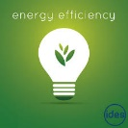
Strategies for Energy Efficiency in Healthcare

Promoting the global initiative of the environmental conservation and green energy code.


References
Trust, H. R. E. (2014). Environmental Sustainability in Hospitals: The Value of Efficiency. Retrieved from http://www.hpoe.org/Reports-HPOE/ashe-sustainability-report-FINAL.pdf

